



BASIC OFFICE SYSTEMS
AND PROCEDURES
(220)

NATIONAL 2024

MULTIPLE CHOICE
25 Questions (2 points each) __________ (50 points)

PRODUCTION
Job 1: Report __________ (100 points)
Job 2: Print 1: Table __________ (100 points)
Print 2: Table with formulas __________ (25 points)
Job 3: News Release __________ (100 points)
Job 4: Letter __________ (100 points)
TOTAL POINTS __________ (475 points)
Test Time: 90 minutes

GENERAL GUIDELINES:
Failure to adhere to any of the following rules will result in disqualification:
- Member must hand in this test booklet and all printouts if any.
- No equipment, supplies, or materials other than those specified for this event are allowed in the testing area. No previous BPA tests and/or sample tests (handwritten, photocopied, or keyed) are allowed in the testing area.
- Electronic devices will be monitored according to ACT standards.
EXAM GUIDELINES:
- Ensure this test booklet contains Jobs 1-4.
- Key all jobs according to the instructions given.
- Correct any and all formatting, spelling or grammar errors. Use the formatting guide in the Style & Reference Manual.
- Your name or initials should not appear on any work you submit. Use your Member ID on any occasion you would normally key your reference initials.
- In the lower right hand corner of ALL work submitted (unless otherwise specified), key your Member ID and job number.
- If you complete the event before the end of the time allotted, notify the proctor. Time may be considered a factor in determining a winner when there is a tie score.
- Place your scoring sheet on top of your jobs. Jobs should be placed in numerical order.

PRODUCTION STANDARDS
0 Errors | 100 Points
1 Error | 90 Points
2 Errors | 70 Points
3 Errors | 50 Points
4+ Errors | 0 Points

Multiple Choice – (25 @ 2 points each)
1. | B | 13. | C
2. | C | 14. | D
3. | C | 15. | C
4. | B | 16. | D
5. | D | 17. | A
6. | B | 18. | B
7. | A | 19. | C
8. | A | 20. | A
9. | B | 21. | A
10. | B | 22. | B
11. | C | 23. | D
12. | A | 24. | B
 |  | 25. | C

Julie Smith
Note to Grader:
First and Subsequent Page Header
Smith 1
JOB 1. Report. [Note to Grader: 1” top margin, 1” side margins. Refer to the Style & Reference Manual for formatting guidelines. Words bolded are spelling or grammatical corrections.]

Harvey Rosen

Vice President of Sales

19 January 20—(current year)
(Note to Grader: Member to select an appropriate title)

The Seaside Fitness Center

The Seaside Fitness Center’s goal is simple: to provide a state-of-the-art exercise facility staffed by highly-skilled professionals in a supportive, healthful environment. By making a commitment to a healthier lifestyle, we believe members will experience an enriched quality of life. Our professional and compassionate staff looks forward to helping you reach your goals and realize the positive results of improving your health.
Benefits of Exercise
Study after study shows that regular physical activity – even at moderate levels, reduces the risk of heart disease, cancer, high blood pressure and obesity, and enhances physical and mental functioning.
Despite this, a report from the Centers of Disease Control and Prevention (CDC) showed that 55% of American adults didn’t move enough in 2021 to meet the minimum recommendation of 30 minutes of moderate physical activity on most days of the week. A Gallup Health Survey found that just 45% of American’s regularly engaged in vigorous exercise in 2022.
The key is to find the right exercise for you. If it is fun, you are more likely to stay motivated.
Getting Started
The path to a regular exercise routine has great reward as well as roadblocks. Our goal is to help make it simple and safe – and give you motivation to push on. According to medical experts, most adults need at least 30 minutes of moderate physical activity at least 5 days per week. If you’ve been inactive for a while, use a sensible approach and start out slowly.
Note to Grader:
First and Subsequent Page Header
Smith 2
Our staff is here to help you establish a safe, healthy, and fun fitness routine that meets your individual needs and goals.
FOOTER: Member ID
Job No.
Job 2: Table: 2 Printouts
Key the following information as a table with borders creating an amortization
schedule. Use the column headings Payment, Interest, Applied to Balance, Loan Balance. Use formulas in the last column to calculate the loan balance. Start with $1,000.00 in the first row under the headings for Loan Balance. The rest of the data should be input starting with the row below $1,000.00. Use the correct format for a table using the Stye and Reference Manual.

The title for the Table should be: Amortization Schedule

Print as follows:

Print 1: Print the completed table
Print 2: Print table with formulas

Grader: Printout 1 will be based on Production Standards and worth 100 Points
Table should be centered horizontally and vertically on the page and follow Style and Reference Manual Guidelines

AMORTIZATION SCHEDULE

Payment | Interest | Applied to Balance | Loan Balance
 |  |  | $1,000.00
$100.00 | $10.00 | $90.00 | $$=D2-C3 910.00$$
100.00 | 9.10 | 90.90 | 819.10
100.00 | 8.19 | 91.81 | 727.29
100.00 | 7.28 | 92.72 | 634.57
100.00 | 6.35 | 93.65 | 540.92
100.00 | 5.41 | 94.59 | 446.33
100.00 | 4.46 | 95.54 | 350.79
100.00 | 3.51 | 96.49 | 254.30
100.00 | 2.54 | 97.46 | 156.84
100.00 | 1.57 | 98.43 | 58.41
100.00 | 0.58 | 58.41 | 0.00

FOOTER: Member ID
Job No.

Job 2: Table: Print 2: Print table with formulas
Grader: Printout 2 will be based on Printing with Formulas worth 25 Points
This Print is worth 25 Points All or Nothing
This Print is not based on Production Standards

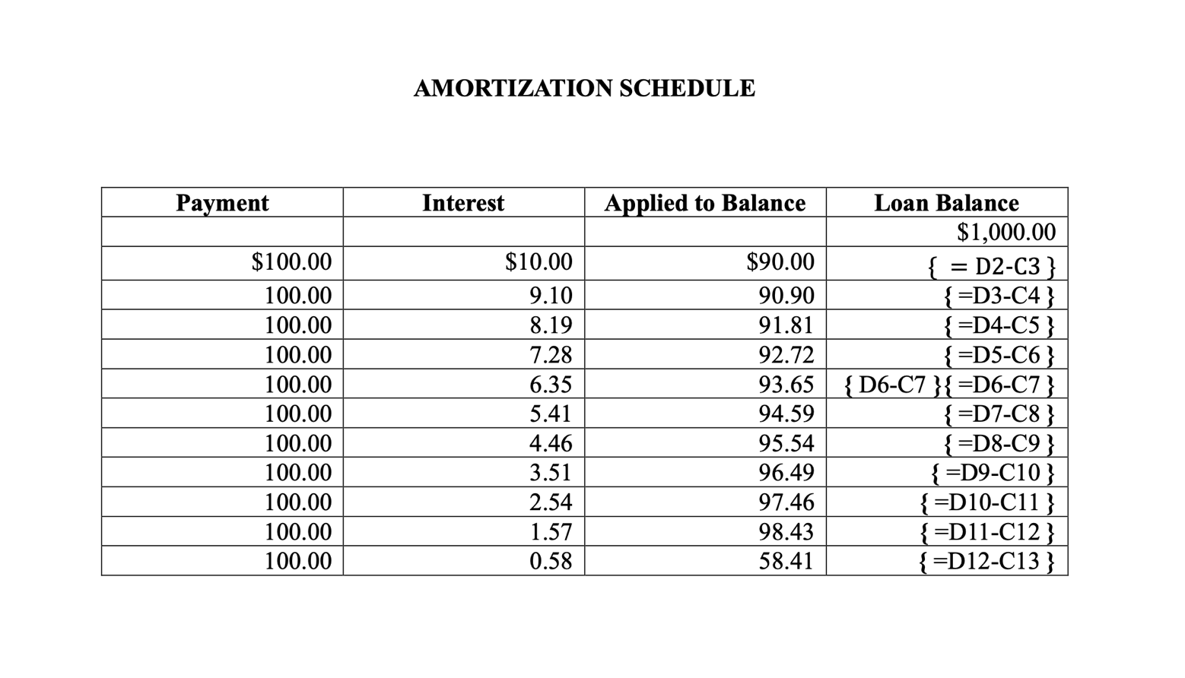

FOOTER: Member ID
Job No.

NEWS RELEASE
Job 3: News Release

From Harvey Rosen
700 Morse Road, Suite 201
Grader: Bolded words were spelling errors and should be corrected. Style and Reference Manual must be followed.
Columbus, OH 43214
614-555-5555

Release June 18, 20—(current year)

NESTLE AND STARBUCKS PARTNER

Nestle today announced the launch of a new range of coffee products under the Starbucks brand to be available globally. The new range consists of 24 products, including whole bean and roast and ground, as well as the first-ever Starbucks capsules developed using Nespresso and Nescafe Dolce Gusto proprietary coffee and system technologies.
This is the first product launch since the two companies formally joined forces in August last year and created a global coffee alliance.
In the coming days, Nestle will start rolling out these products in several markets across Asia, Europe, Latin America, Middle East and the U.S. Customers around the world will be able to enjoy their favorite Starbucks coffee at home when the products will become widely available in grocery stores and major online platforms.
# # #

FOOTER: Member ID
Job No.

January 22, 20 - -(current year)
Job 4: Letter

Grader: Bolded words were spelling errors and should be corrected. Style and Reference Manual must be followed.

Ms. Nancy Wells, President
Digital Solutions
7211 Waterman St
Boulder, CO 80301

Dear Ms. Wells

FINAL AUDIT REPORT

Enclosed is your final audit report completed by Varney CPAs. The report covers the period from October 1, 2022 to September 30, 2023. Your response has been incorporated into the final report in the appendix.

I would like to express my appreciation for all of the courtesy extended to my staff during the course of the fieldwork.

If you have any questions concerning this matter, please contact Heather Varney, Senior Auditor, at 555-555-5555.

Sincerely

Julie Smith
Certified Public Accountant

#############

Enclosure

c Harvey Rosen
FOOTER: Member ID
Job No.

